MULTIMEDIA WEB AND DESIGN HOMEWORK WITH JAVASCRIPT
Introduction to JavaScript

Eda Selmani – ID: 1006689

Block 1 The Browser Console
Exercise 1.1 — Your first line of code
Type the following in your browser console and press Enter:

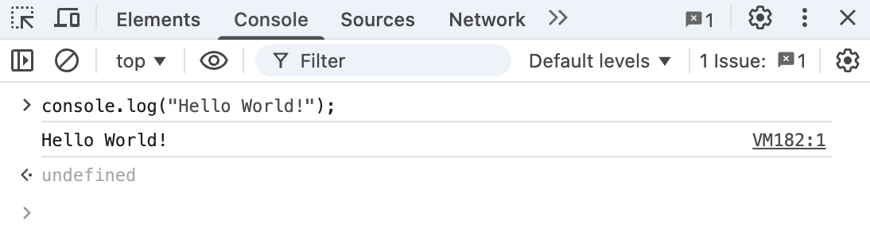

Exercise 1.2 — Basic arithmetic
JavaScript can work like a calculator. Type each of these one at a time:

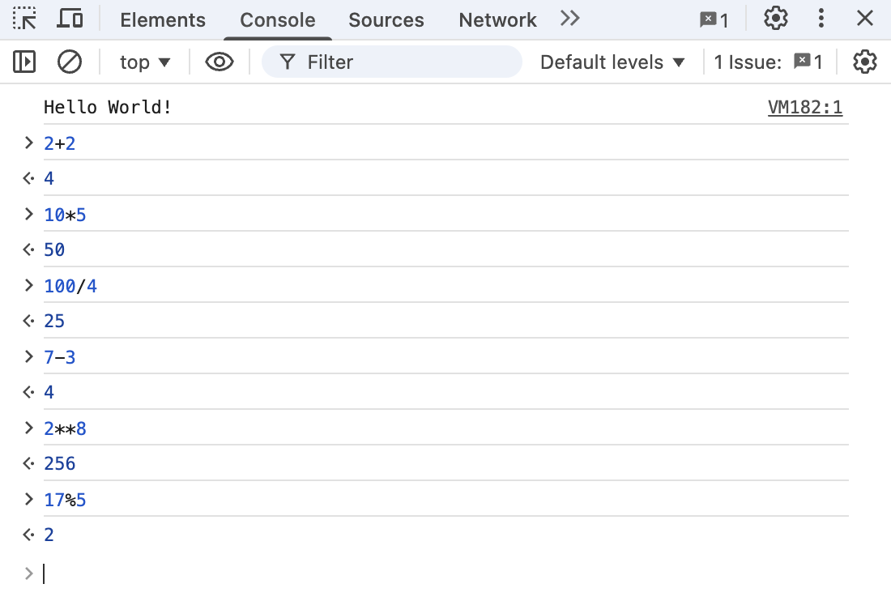

Block 2 Variables and Data Types
Exercise 2.1 — Declaring variables
Type this code in your console or editor, one line at a time:

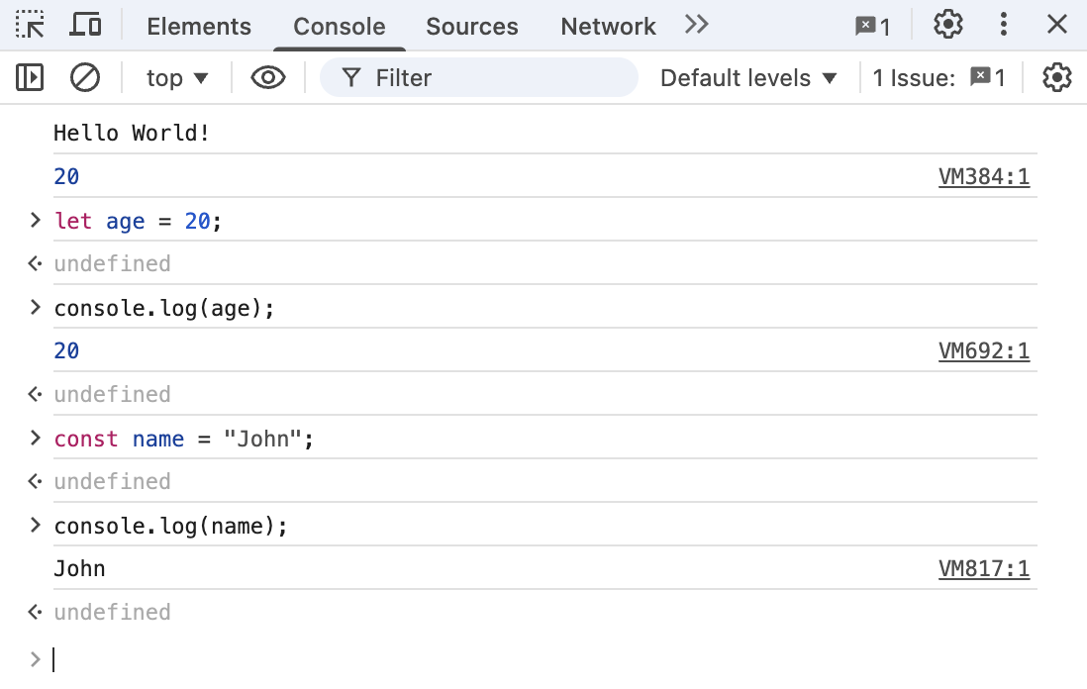

Exercise 2.2 — Data types
JavaScript has several built-in types. Here are the some that you will use most as a beginner:

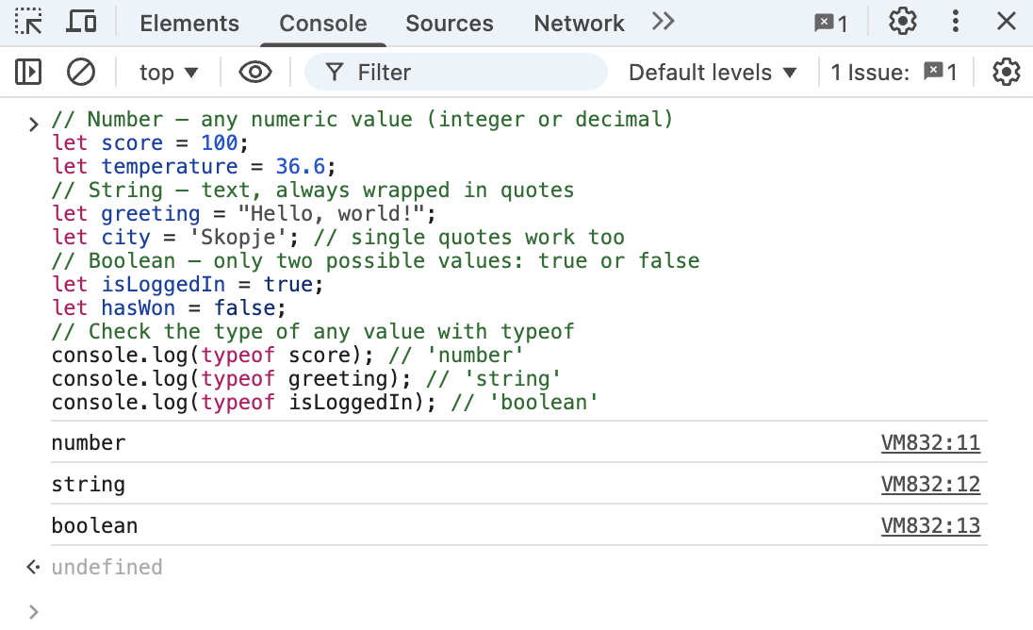

Exercise 2.3 — String operations
Strings are not just static text — you can manipulate them:

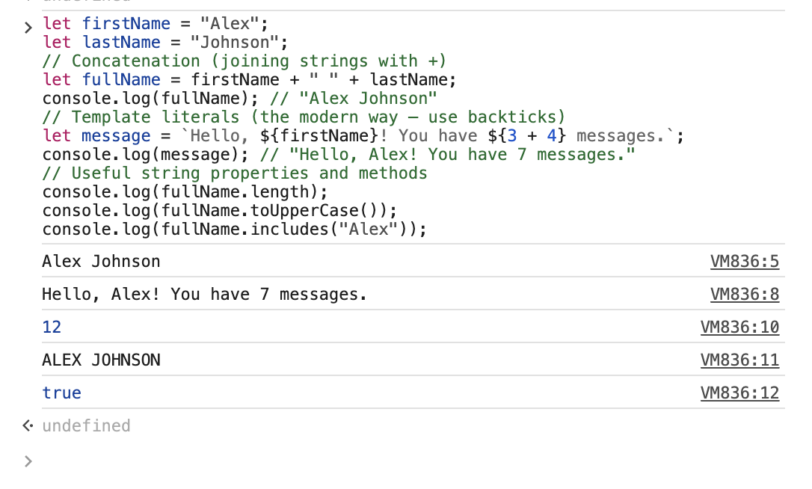

Block 3 Functions
Exercise 3.1 — Your first function

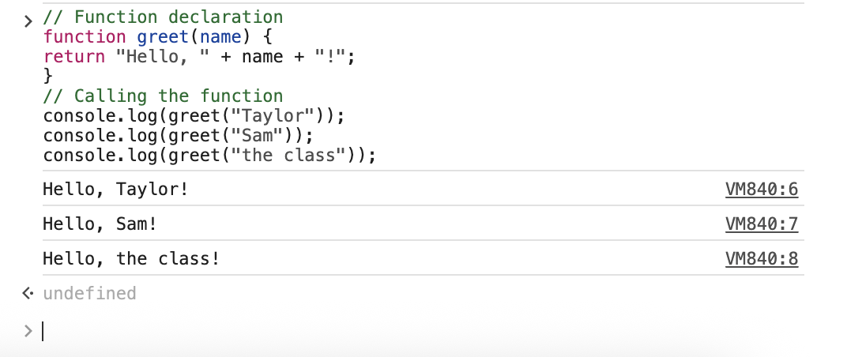

Exercise 3.2 — Arrow functions
Arrow functions are a shorter way to write functions.

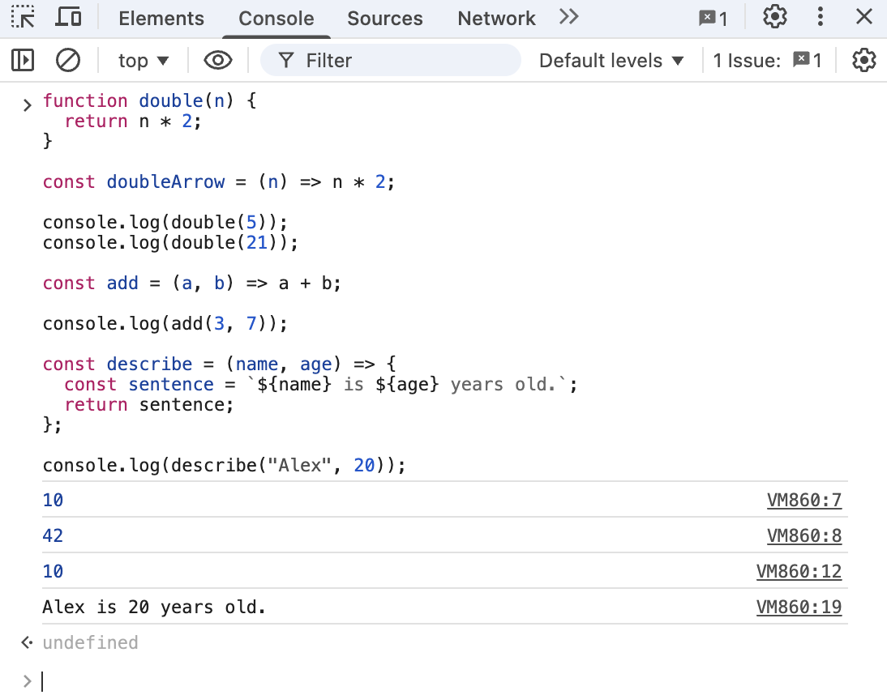

Exercise 3.3 — Challenge: isEven
Write a function that returns true if a number is even, and false if it is odd.

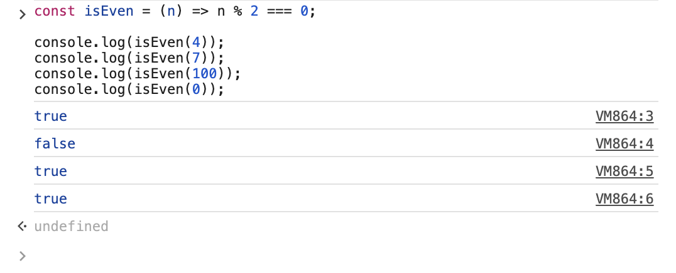

Block 4 Conditionals and Loops
Exercise 4.1 — if / else
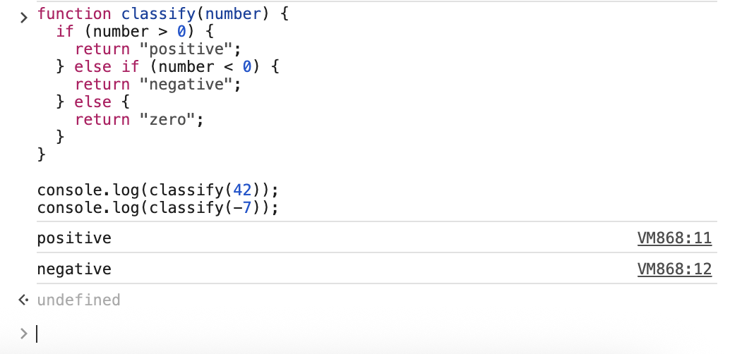

Exercise 4.2 — for loop
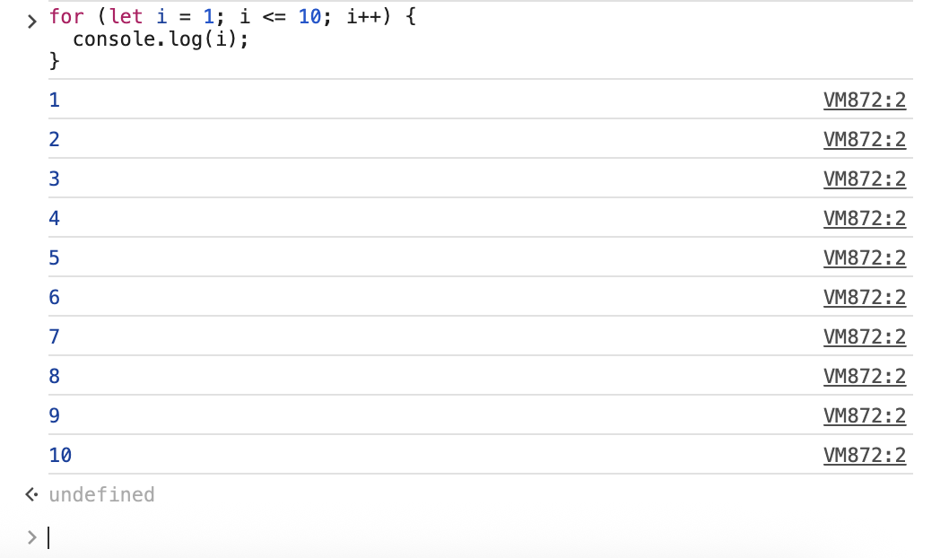

Exercise 4.3 — Combining conditionals and loops
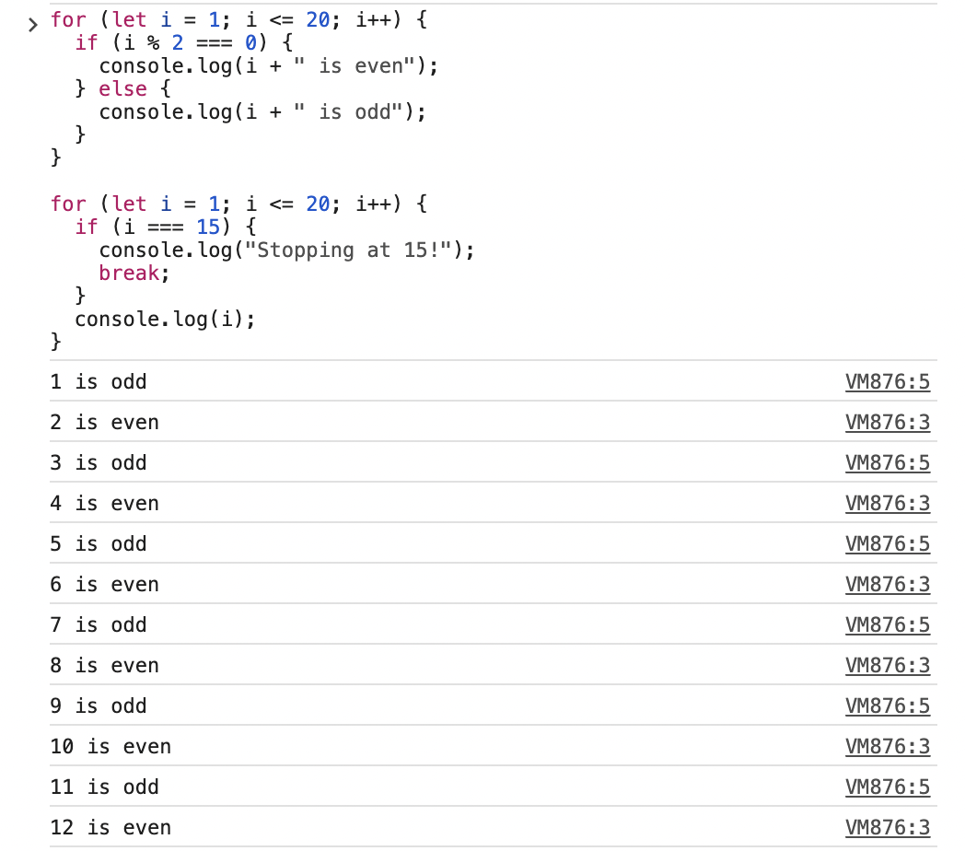
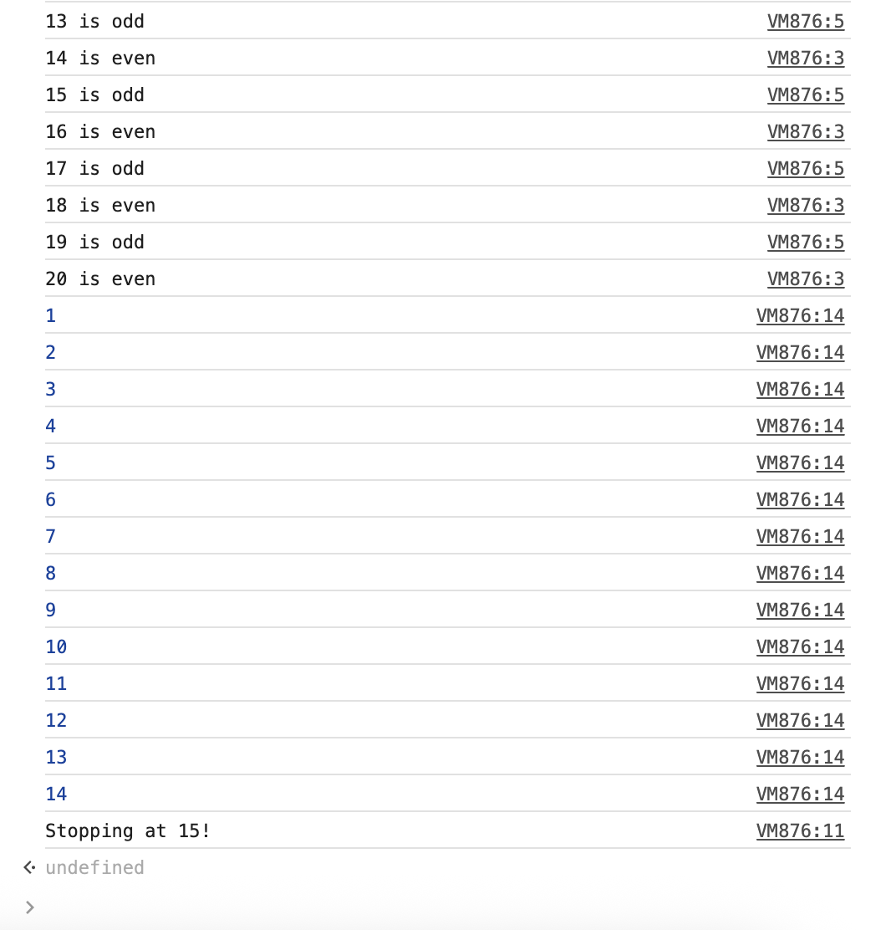

Block 5 Mini Challenge: FizzBuzz
Step-by-step solution
Try writing the solution yourself first.
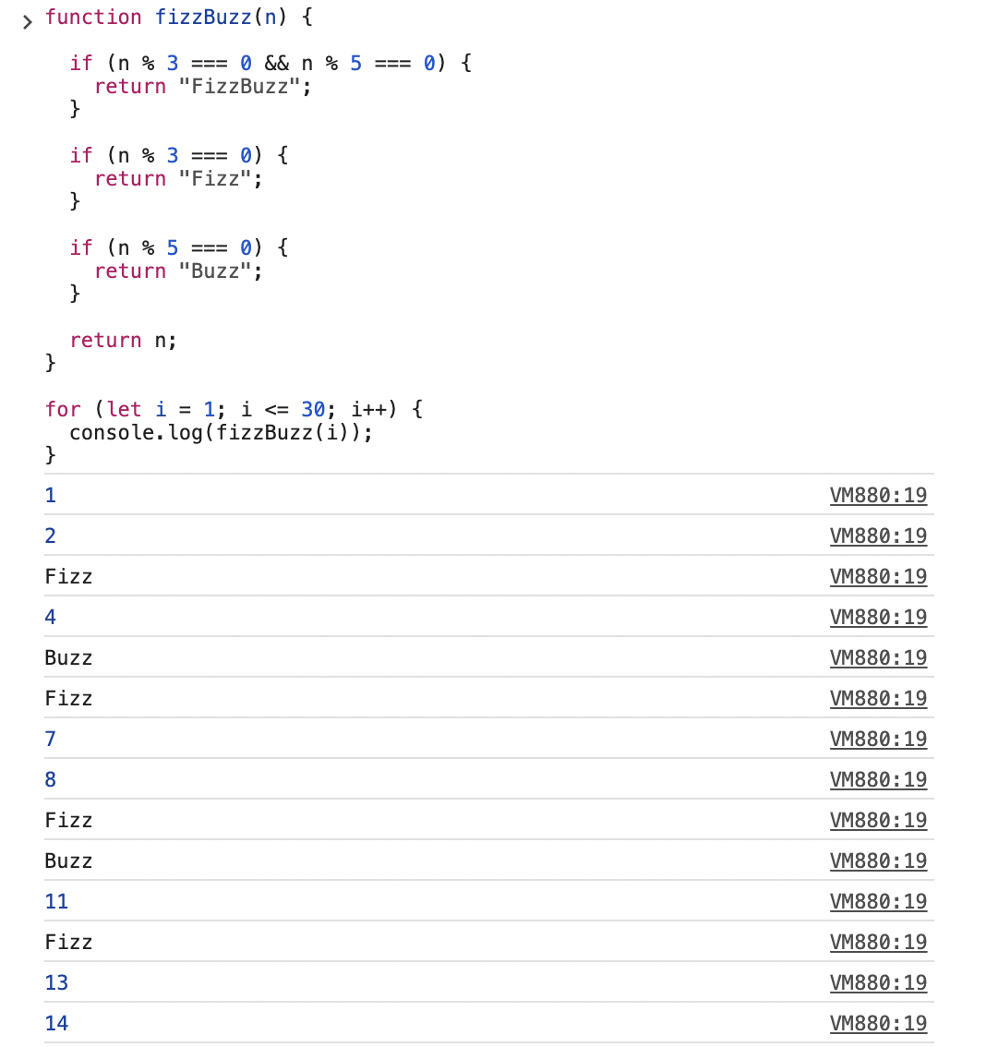

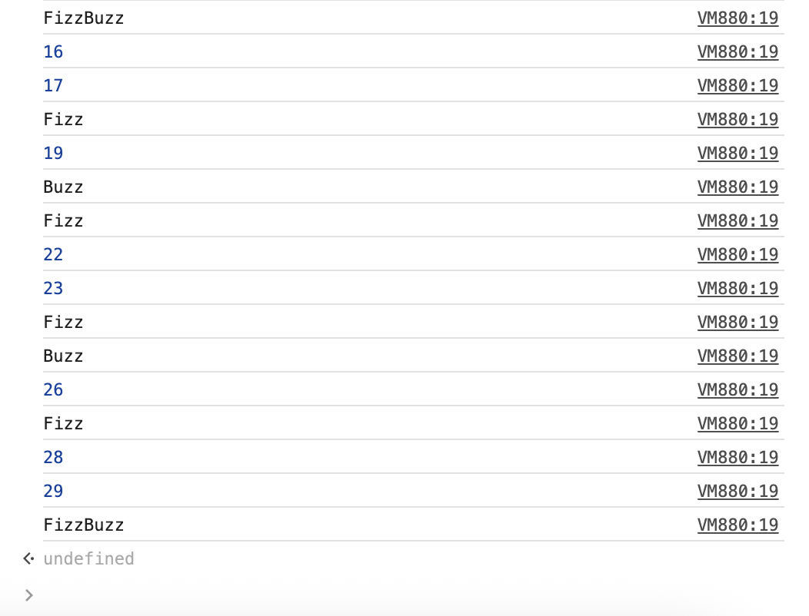

Bonus challenge — add 'Whizz'
